**Personal Development Journal**



Adam Logan

Table Of Contents

**1. Week Commencing 23/01/23 2**

**2. Week Commencing 30/01/23 2**

**3. Week Commencing 06/02/23 3**

**4. Week Commencing 13/02/23 3**

**5. Week Commencing 20/02/23 4**

**6. Week Commencing 27/02/23 4**

**7. Week Commencing 06/03/23 5**

**8. Week Commencing 13/03/23 6**

**9. Week Commencing 20/03/23 7**

**10. Week Commencing 27/03/23 8**

**11. Week Commencing 03/04/23 9**

**12. Week Commencing 10/04/23 9**

**13. Week Commencing 17/04/23 10**

**14. Week Commencing 24/04/23 11**

**15. Week Commencing 01/05/23 11**

**16. Wider Reading 12**

**17. Figures 13**

# 1. WEEK COMMENCING 23/01/23

|  |  |  |
| --- | --- | --- |
| Entry Number: 01 | Date: 26/01/2023 | Week Number: 03 |
| What was done | * Prepared for the meeting with Charles Gillan and Lisa McIlmurray, by having a meeting beforehand to produce questions * Had an introductory meeting with Charles Gillan and Lisa McIlmurray, in which the questions above were asked * Organised a google drive allowing the team to share and corporate on documents | |
| What went well | * Everyone contributed questions to ask Charles Gillan and Lisa McIlmurray * We agreed on what collaborative tool to work on the documentation | |
| What went badly | * The start of the meeting, preparation meeting was slow as no one had prepared anything beforehand | |
| What to continue | * Ensuring everyone has a chance to contribute | |
| What to improve on | * We should have prepared work prepared before meetings are conducted, | |

# 2. WEEK COMMENCING 30/01/23

|  |  |  |
| --- | --- | --- |
| Entry Number: 02 | Date: 31/01/23 | Week Number: 04 |
| What was done | * The team divided the work for the first submission * The team decided what was necessary for each section of the submission * Researched technologies which could possibly be used for the project | |
| What went well | * An agreement to an internal deadline before the submission to allow team members to review the material * Delegating dedicated ‘support’ people to individual tasks | |
| What went badly | * N/A | |
| What to continue | * To delegate a ‘support’ person to each task to assist the main contributor | |
| What to improve on | * N/A | |

# 

# 3. WEEK COMMENCING 06/02/23

|  |  |  |
| --- | --- | --- |
| Entry Number: 03 | Date: 10/02/23 | Week Number: 05 |
| What was done | * Made further progress on the high level specification * Discussed, with the team, the features to prioritise for the prototype * The team set up a Jira project and a GitLab repository * The team divided the problem analysis into different sections and allocated these to each member * Researched academic articles in relation to JavaScript frameworks [1][2][3] | |
| What went well | * Planned for what was needed before starting the prototype | |
| What went badly | * Difficulty finding relevant articles comparing against the different frameworks | |
| What to continue | * Before starting a task, what is required to complete the task should be organised first | |
| What to improve on | * Expand the search used, when looking for articles * To plan ahead for future deliverables | |

# 4. WEEK COMMENCING 13/02/23

|  |  |  |
| --- | --- | --- |
| Entry Number: 04 | Date: 15/02/23 | Week Number: 06 |
| What was done | * Researched and found references for the technology choices to be made [4][5] * Finalised the technology choices for the team to review * Reviewed the work that was completed by the other members of the team * Contributed to the ‘Problem Vision’ sections, on the discussion of visualisations * Created a draft requirements document | |
| What went well | * Being able to suggest changes on other team members section * Used what was learned in Entry 03 and expanded the search, which allowed successful location of useful papers to reference and some which expanded my knowledge within several computing related areas | |
| What went badly | * During the team meeting, on this day we decided that we had left starting the deliverable for SDP1 too late | |
| What to continue | * To use the ‘reviewing’ feature of microsoft word to review each other's work * To look at academic papers, which at first do not seem relevant, as they may still contain useful information | |
| What to improve on | * To assign the work for the deliverables sooner * To have 3 meetings a week instead of the 2, which we have been having | |

|  |  |  |
| --- | --- | --- |
| Entry Number: 05 | Date: 17/02/23 | Week Number: 06 |
| What was done | * Team created the user personas * Written ‘Use Case Scenario 2’ within ‘Use Case Scenario’ * Team made some revisions to SDP1 and completed the document | |
| What went well | * Reviewed the suggestions made to the document, together | |
| What went badly | * Formatting the document itself took a considerable amount of time | |
| What to continue | * To go through the suggestions, made by other members, as a team allowing for the rest of the team to provide their input | |
| What to improve on | * Allow for a greater time buffer, between the deadline and finalising the report | |

# 5. WEEK COMMENCING 20/02/23

|  |  |  |
| --- | --- | --- |
| Entry Number: 06 | Date: 23/02/23 | Week Number: 07 |
| What was done | * Added the ‘Fit Criterion’ to the draft requirements * Reviewed the suggestions made to the draft requirements * The team reviewed the submission for SDP1, made final changes and submitted | |
| What went well | * The sections produced by separate team members flowed well together | |
| What went badly | * Formatting the word document at the very end was difficult | |
| What to continue | * To continue to discuss and review each individual section when it is being written, so advice can be given when a team member is working on their own section | |
| What to improve on | * During the course of writing the report the formatting of the document should be decided on, to prevent time being spent on this before submission | |

# 6. WEEK COMMENCING 27/02/23

|  |  |  |
| --- | --- | --- |
| Entry Number: 07 | Date: 28/02/23 | Week Number: 08 |
| What was done | * The team created a full backlog on Jira * Assigned which sections each team member will complete for the report deliverable as learnt from Entry 04 * Created a new format for the requirements [6][7] * Expanded on the existing draft requirements * Completed the ‘Docker 101’ tutorial [8] | |
| What went well | * The team worked well in dividing tasks into epics, user stories and issues | |
| What went badly | * N/A | |
| What to continue | * To use Jira effectively to ensure visibility of each team member's assigned tasks | |
| What to improve on | * N/A | |

|  |  |  |
| --- | --- | --- |
| Entry Number: 08 | Date: 03/03/23 | Week Number: 08 |
| What was done | * [Created a template to build APIs for the system, with the required dependencies installed](https://gitlab2.eeecs.qub.ac.uk/40293585/svs-paediatric-delerium/-/commit/fd715a0bc7fa3920bd9f4e93de0209f585f920ce) * [Created a template to build React apps, with the required dependencies installed](https://gitlab2.eeecs.qub.ac.uk/40293585/svs-paediatric-delerium/-/commit/d111e2d620a3df989d295674b5dfce74738c10a3) * Expanded upon the existing draft requirements * Further researched Docker [9][10][11] * Completed the intro to React tutorial [12] | |
| What went well | * Gained a greater understanding of Docker, specifically around the Dockerfile and docker-compose.yml | |
| What went badly | * Very complex to create the file structure of the react app without first reading the literature and completing a beginner’s tutorial | |
| What to continue | * To research technologies that may be useful to the project | |
| What to improve on | * Before using a new technology and general reading of the literature should be conducted as demonstrated by the difficulties faced with React during this entry compared to the understanding gained from Docker | |

# 7. WEEK COMMENCING 06/03/23

|  |  |  |
| --- | --- | --- |
| Entry Number: 09 | Date: 07/03/23 | Week Number: 09 |
| What was done | * [Created a custom hook for a get HTTP request](https://gitlab2.eeecs.qub.ac.uk/40293585/svs-paediatric-delerium/-/commit/a74e581d9539d0e36ffec5193ec64b0a80fb1282) * [Created a component which displays the output of a HTTP request](https://gitlab2.eeecs.qub.ac.uk/40293585/svs-paediatric-delerium/-/commit/a74e581d9539d0e36ffec5193ec64b0a80fb1282) * As a team, decided on the architecture of the system (Figure 17.1) * As a team, developed several wireframe diagrams for the system   (Figure 17.2)(Figure 17.3) | |
| What went well | * Having completed the tutorials above, it was relatively simple to integrate the APIs into the project | |
| What went badly | * The frontend cannot send a request to the local API, but can receive it can send a request to APIs that are not hosted locally | |
| What to continue | * To look in depth for current solutions/tutorials before starting to implement a feature | |
| What to improve on | * To research beforehand the differences of hosting the system on the local machine and on the server, this understanding may also prevent issues in the future | |

|  |  |  |
| --- | --- | --- |
| Entry Number: 10 | Date: 10/03/23 | Week Number: 09 |
| What was done | * Assisted the team in connecting with GitLab and ensured that the example project worked on all machines * Explained the basics of React and the file structure that was created, with the team * Had a meeting with Lisa McIlmurray and Charles Gillan and discussed about the requirements of the system * Revised the requirements based on the meeting with Lisa McIlmurray and Charles Gillan | |
| What went well | * A lot of information was gathered within the meeting with Lisa McIlmurray and Charles Gillan due to what was learnt from Entry 01 | |
| What went badly | * Experienced difficulties in setting up GitLab on all team member’s machines | |
| What to continue | * Before meetings with the project champions (Lisa McIlmurray and Charles Gillan) prepare a list of questions beforehand | |
| What to improve on | * To save useful links/tutorials in a form easily accessible to all team members | |

# 

# 8. WEEK COMMENCING 13/03/23

|  |  |  |
| --- | --- | --- |
| Entry Number: 11 | Date: 18/03/23 | Week Number: 10 |
| What was done | * At the beginning of the week (14/03/23) assigned wire frame diagrams to Robbie Duncan and Ewan Forsythe, while Andrew Robb is to begin the ‘Implementation’ section for the report * [Created a dockerfile for ‘APIs’](https://gitlab2.eeecs.qub.ac.uk/40293585/svs-paediatric-delerium/-/commit/c9d16b67407185b12c125efdd5f3d475366c21c2) * [Created a dockerfile for ‘example-frontend’](https://gitlab2.eeecs.qub.ac.uk/40293585/svs-paediatric-delerium/-/commit/66e5e31a50c4827fd88aaaaca68223c14b5cc7e7) * [Fixed the bug were the ‘APIs’ and ‘example-frontend’ containers were not restarting when a change was made to the source files for the individual projects](https://gitlab2.eeecs.qub.ac.uk/40293585/svs-paediatric-delerium/-/commit/66e5e31a50c4827fd88aaaaca68223c14b5cc7e7) | |
| What went well | * Fixed the bug, described above, with relative ease | |
| What went badly | * N/A | |
| What to continue | * To save useful links as these were beneficial when looking for the solution for the bug * Assigning work directly for the deliverable, with a significant time buffer until the deadline * Researched about the topic at hand before attempting the problem, as this allowed for the quick bug fix | |
| What to improve on | * N/A | |

# 9. WEEK COMMENCING 20/03/23

|  |  |  |
| --- | --- | --- |
| Entry Number: 12 | Date: 22/03/23 | Week Number: 11 |
| What was done | * [Created a simple API that demonstrates connection with database](https://gitlab2.eeecs.qub.ac.uk/40293585/svs-paediatric-delerium/-/commit/ea32a1204b941191c3178cd022b595302050ff19) * [Investigated having a ‘local’ copy of the postgres server that could be shared with the other members through git](https://gitlab2.eeecs.qub.ac.uk/40293585/svs-paediatric-delerium/-/commit/fbd9e1edbf3e3dd83bff33f5df7e608c498f3301) * [Created ‘setup’ scripts for the postgres server](https://gitlab2.eeecs.qub.ac.uk/40293585/svs-paediatric-delerium/-/commit/16f3929fe7b6c16245894f6a467f00c49c040223) [13] [14] [15] [16] | |
| What went well | * Quickly found potential solutions for having a ‘local’ copy of the postgres server, and tested these with relative ease although it was found this was not possible little time was spent on this and the ‘setup’ scripts workaround was devised * As learnt from Entry 08 before creating the ‘setup’ scripts, general reading of the literature on shell scripts was conducted which assisted in understanding the script | |
| What went badly | * N/A | |
| What to continue | * To examine the root cause of the problem and to be open to all possible solutions | |
| What to improve on | * N/A | |

|  |  |  |
| --- | --- | --- |
| Entry Number: 13 | Date: 24/03/23 | Week Number: 11 |
| What was done | * Tested ‘setup’ bash script on other team members PC * [Created functions that would generate ‘select’ and ‘insert’ queries](https://gitlab2.eeecs.qub.ac.uk/40293585/svs-paediatric-delerium/-/commit/9e09c64535db24b89cab917353b440ce03135a8b) * [Created ‘startup’ scripts that allows the program to be started](https://gitlab2.eeecs.qub.ac.uk/40293585/svs-paediatric-delerium/-/commit/a7e45e736253a00d8ee12c50a38eb54d36dfdd0d) [17] [18] [19] * [Added an API that can insert data into the database](https://gitlab2.eeecs.qub.ac.uk/40293585/svs-paediatric-delerium/-/commit/f60cee27755afbb31c5d222886c7d4d0bdb14e13) | |
| What went well | * Creating the ‘startup’ scripts went smoothly as a better understanding of shell scripts was gained from the ‘setup’ script bug which is stated in ‘What went badly’ * As stated in Entry 08 and Entry 12, before starting relatively simple pieces of work which contain a new technology, in this case being PowerShell, it was helpful to read the literature to gain a better understanding | |
| What went badly | * A simple error, in regard to the ‘setup’ bash script, took much longer to resolve than was necessary as the error message was not read properly. The issue at hand was that the script itself was developed on a Windows machine and therefore was in the incorrect format to be executed on the Linux VM used by Docker | |
| What to continue | * To document solutions to bugs/errors that we encounter to assist in resolving future bugs/errors | |
| What to improve on | * To read error messages, closely, to diagnose an issue rather than going straight to looking for a solution on the internet | |

# 10. WEEK COMMENCING 27/03/23

|  |  |  |
| --- | --- | --- |
| Entry Number: 14 | Date: 27/03/23 | Week Number: 12 |
| What was done | * [Created an API that updates data in a database](https://gitlab2.eeecs.qub.ac.uk/40293585/svs-paediatric-delerium/-/commit/3f3a6e974dd8a3637d7cdae256815265b21de032) * [Created an API that deletes data in a database](https://gitlab2.eeecs.qub.ac.uk/40293585/svs-paediatric-delerium/-/commit/6a0e7dfb7a7b3b0d3c6cfbe0f0fa1460485697a4) * [Updated comments to the JSDOC standard](https://gitlab2.eeecs.qub.ac.uk/40293585/svs-paediatric-delerium/-/commit/223d42586bb6b83f49f4e03817c44d4886f54f2c) * [Updated the main README to follow a more standardised format along with taking advantage of the GitLab flavoured markdown](https://gitlab2.eeecs.qub.ac.uk/40293585/svs-paediatric-delerium/-/commit/1716c83f1978b11008fc0d91874fe5c0844bb1ef) [20][21] * Completed the requirements document | |
| What went well | * Implemented the ‘update’ and ‘delete’ APIs with relative ease | |
| What went badly | * Took time fixing comments and the README, instead of focusing on work that specifically agreed upon with the team | |
| What to continue | * To continue to review older code as solutions to current issues may have been solved previously | |
| What to improve on | * Instead of going back to change the README and comments the standards for these should have been agreed before the files were created | |

|  |  |  |
| --- | --- | --- |
| Entry Number: 15 | Date: 29/03/23 | Week Number: 12 |
| What was done | * The team meet for an extended in person meeting to begin frontend development and review previous work done   + Reviewed wireframes that were completed by other team members   + Reviewed the requirements   + [Conducted peer programming by starting on a landing page for the audit system](https://gitlab2.eeecs.qub.ac.uk/40293585/svs-paediatric-delerium/-/commit/8d2e26d79b3b3fb75224d99cd5cbf676228da2ea) [22] (Figure 17.4) (Figure 17.5) * [Further developed the audit landing page once the meeting ended](https://gitlab2.eeecs.qub.ac.uk/40293585/svs-paediatric-delerium/-/commit/a39dcc0747c2557b57062aa2cf186d7af97844f9) * [Created the login page for the audit system](https://gitlab2.eeecs.qub.ac.uk/40293585/svs-paediatric-delerium/-/commit/68d7b21d80dcef708339147df44466f9abf5e206) * [Changed the ‘username’ field to a filtered dropdown](https://gitlab2.eeecs.qub.ac.uk/40293585/svs-paediatric-delerium/-/commit/e36a5bd6bffa28f633cc2a17668cea491daf99e5) [23] | |
| What went well | * Agreed upon coding standards which the team will follow and allowed the team to have the same understanding of how the technology works | |
| What went badly | * Took too much time focusing on small details about the styling of the landing page, preventing progress within the meeting | |
| What to continue | * Starting large pieces of work within a peer programming session | |
| What to improve on | * When peer programming in the future, it is important to leave small issues/bugs for an individual to work on and focus on the larger issues/bugs | |

# 11. WEEK COMMENCING 03/04/23

|  |  |  |
| --- | --- | --- |
| Entry Number: 16 | Date: 03/04/23 | Week Number: 13 |
| What was done | * Reviewed the testing document created by Ewan Forsythe * Wrote problem statement, for the requirements section * Wrote elicitation and analysis process, for the requirements section | |
| What went well | * Managed to view the resources used during the elicitation process, as these resources were kept due to what was learnt from Entry 10 * As learnt from Entry 06 it was helpful to review Ewan Forsythe’s work when only a few test cases were created as changes could be made to the column headers without affecting too many test cases | |
| What went badly | * N/A | |
| What to continue | * Keep a record of previous resources used | |
| What to improve on | * N/A | |

|  |  |  |
| --- | --- | --- |
| Entry Number: 17 | Date: 07/04/23 | Week Number: 13 |
| What was done | * Created ER diagrams * [Created audit database along with the triggers to calculate the compliance score](https://gitlab2.eeecs.qub.ac.uk/40293585/svs-paediatric-delerium/-/commit/bc244b85997090be174152ab72412c6ee0cebf1a) * Wrote section 5.1 project management, for the report | |
| What went well | * The detailed requirements and the resources provided by Lisa McIlmurray, allowed for a base to design both databases | |
| What went badly | * N/A | |
| What to continue | * Communicate with Lisa McIlmurray and to view the existing system for inspiration | |
| What to improve on | * N/A | |

# 12. WEEK COMMENCING 10/04/23

|  |  |  |
| --- | --- | --- |
| Entry Number: 18 | Date: 10/04/23 | Week Number: 14 |
| What was done | * [Created a login and authenticate endpoints](https://gitlab2.eeecs.qub.ac.uk/40293585/svs-paediatric-delerium/-/commit/6fe53c480a898c137bc340983489e585d94a3d91) * [Authenticated the page routes of the application](https://gitlab2.eeecs.qub.ac.uk/40293585/svs-paediatric-delerium/-/commit/f4483ec010af2a87ffc3e83b28e81985e1861dc0) * Merged all the branches into main | |
| What went well | * Both the endpoints were developed with relative ease, due to research conducted beforehand | |
| What went badly | * There was a few merge conflicts which proved difficult to solve | |
| What to continue | * To conduct research on functionality which is relatively common to other systems | |
| What to improve on | * Better communication between members of the team when developing | |

|  |  |  |
| --- | --- | --- |
| Entry Number: 19 | Date: 14/04/23 | Week Number: 14 |
| What was done | * [Created endpoints to retrieve the data used for the graph](https://gitlab2.eeecs.qub.ac.uk/40293585/svs-paediatric-delerium/-/commit/93238e37902e9fa075db3bd25483bae201a51c6b) * [Hashed passwords](https://gitlab2.eeecs.qub.ac.uk/40293585/svs-paediatric-delerium/-/commit/4cf7ca23c2ce3db31ac5d179590f22cb44d7d002) * [Fixed bug with the roles within the database](https://gitlab2.eeecs.qub.ac.uk/40293585/svs-paediatric-delerium/-/commit/82bb5d7fc41825e7459b2a0c4a3dc42b0d9ad866) * [Added pgAdmin4 to view the database](https://gitlab2.eeecs.qub.ac.uk/40293585/svs-paediatric-delerium/-/commit/0d7c29e2dcd57f6826db0263a9105ab909cea35d) | |
| What went well | * Due to previous experience with Docker adding pgAdmin4 went smoothly | |
| What went badly | * Issue with installing the correct packages * The original plan to hash the passwords on the client side to prevent the plain text password being sent to the API did not work as the ‘.compare()’ function requires the plain text password and this functionality is incorporated on the server side   + As the passwords were salted it is was not possible to check if the string from the database was the same as the hashed string * There was an issue with the roles, within the database where the field engineer and PICU roles could only view the compliance data table and not insert data into it, even when this was explicitly granted | |
| What to continue | * Leaning on the skills developed throughout the project * The bug, in regard to the roles, was resolved with relative ease due to the lesson to read error messages closely learned in Entry 13 | |
| What to improve on | * Instead of assuming what arguments are valid for a particular function, the documentation should be checked * To improve our testing methodology as the role error should have been detected when the roles were created | |

# 13. WEEK COMMENCING 17/04/23

|  |  |  |
| --- | --- | --- |
| Entry Number: 20 | Date: 18/04/23 | Week Number: 15 |
| What was done | * Team created the slides for the presentation * Team worked on use case diagrams * [Andrew Robb and myself, conducted a pair programming session that, worked on the ‘Audit Graph’ functionality](https://gitlab2.eeecs.qub.ac.uk/40293585/svs-paediatric-delerium/-/commit/38904568249821c7a0ea3e35552b4f806a5f27b4) * Created the high-level architecture diagram * Created E-Learning [database](https://gitlab2.eeecs.qub.ac.uk/40293585/svs-paediatric-delerium/-/commit/01c573cb7a3219f595d10d80693aede99fdb376d) and [roles](https://gitlab2.eeecs.qub.ac.uk/40293585/svs-paediatric-delerium/-/commit/5f95332086c6b0051e24203a61221df61b84026b) * [Created a Python script to generate dummy data for the database](https://gitlab2.eeecs.qub.ac.uk/40293585/svs-paediatric-delerium/-/commit/73374c729ba04207fb979ab427e25a90c28513d7) | |
| What went well | * Was well coordinated when working together on the presentation | |
| What went badly | * Time spent on fixing a bug where the endpoint would not be called when the page first loads but would call the endpoint on refresh | |
| What to continue | * Ensure that all team members are aware of the end goals of the task and that each members work ‘flows’ correctly into each section | |
| What to improve on | * Although a peculiar error, the solution was to simply remove the custom hook and to invoke the code directly and therefore simple fixes, such as this one, should be tested before other more complex solutions | |

# 14. WEEK COMMENCING 24/04/23

|  |  |  |
| --- | --- | --- |
| Entry Number: 21 | Date: 28/04/23 | Week Number: 16 |
| What was done | * The team had a review, at the start of the week, of how the live demonstration (that occurred on 20/04/23) went and possible improvements to the application * Conducted reviews on Robbie Duncan’s, Ewan Forsythe’s and Andrew Robb’s report sections for the final submission and suggested changes | |
| What went well | * Had plenty of time to review the documents before the submission deadline and therefore changes could be made due to what was learnt from Entry 11 | |
| What went badly | * N/A | |
| What to continue | * Set internal deadlines, with a large time buffer between the external deadline, to allow for other members of the team to review the work that was completed | |
| What to improve on | * N/A | |

# 15. WEEK COMMENCING 01/05/23

|  |  |  |
| --- | --- | --- |
| Entry Number: 22 | Date: 05/05/23 | Week Number: 17 |
| What was done | * Conducted a user evaluation of the system with Dean Logan, a colleague on the PwC apprenticeship programme * The team worked on section 5.3 sprint plan * The team conducted user evaluations of the system with Charles Gillan and Lisa McIlmurray * Modified the requirements based on the feedback given from Charles Gillan and Lisa McIlmurray * Formatted and finalised the report several days before submission | |
| What went well | * Beneficial to work together on the sprint plan as it required discussion of what the team thought was feasible to achieve within 4 weeks * As proven in Entry 05 it takes longer than expected to finalise the report and by doing this several days before submission allowed for this time was available | |
| What went badly | * The form that was created did not obtain focused feedback | |
| What to continue | * Work together on sections of the report that require future planning * Have the deliverables in a ‘done’ state with a large time buffer before the deadline to allow for small details to be changed | |
| What to improve on | * To use less open-ended questions to get specific feedback on the areas that most require feedback | |

# 

# 16. WIDER READING

1. S. Delcev and D. Draskovic, "Modern JavaScript frameworks: A Survey Study," 2018 Zooming Innovation in Consumer Technologies Conference (ZINC), Novi Sad, Serbia, 2018, pp. 106-109, doi: 10.1109/ZINC.2018.8448444.
2. C. M. Novac, O. C. Novac, R. M. Sferle, M. I. Gordan, G. BUJDOSó and C. M. Dindelegan, "Comparative study of some applications made in the Vue.js and React.js frameworks," 2021 16th International Conference on Engineering of Modern Electric Systems (EMES), Oradea, Romania, 2021, pp. 1-4, doi: 10.1109/EMES52337.2021.9484149.
3. T. Kaushalya and I. Perera, "Framework to Migrate AngularJS Based Legacy Web Application to React Component Architecture," 2021 Moratuwa Engineering Research Conference (MERCon), Moratuwa, Sri Lanka, 2021, pp. 693- 698, doi: 10.1109/MERCon52712.2021.9525659.
4. K. Saundariya, M. Abirami, K. R. Senthil, D. Prabakaran, B. Srimathi and G. Nagarajan, "Webapp Service for Booking Handyman Using Mongodb, Express JS, React JS, Node JS," 2021 3rd International Conference on Signal Processing and Communication (ICPSC), Coimbatore, India, 2021, pp. 180-183, doi: 10.1109/ICSPC51351.2021.9451783.
5. I. S. Vershinin and A. R. Mustafina, "Performance Analysis of PostgreSQL, MySQL, Microsoft SQL Server Systems Based on TPC-H Tests," 2021 International Russian Automation Conference (RusAutoCon), Sochi, Russian Federation, 2021, pp. 683-687, doi: 10.1109/RusAutoCon52004.2021.9537400.
6. I. Sommerville, Software engineering 10th Edition. Pearson Education, 2016.
7. D. T. Haley, B. Nuseibeh, H. C. Sharp and J. Taylor, "The conundrum of categorising requirements: managing requirements for learning on the move," Proceedings. 12th IEEE International Requirements Engineering Conference, 2004., Kyoto, Japan, 2004, pp. 309-314, doi: 10.1109/ICRE.2004.1335688.
8. Docker. “Docker 101 Tutorial.” Docker, https://www.docker.com/101-tutorial/ Accessed 28 February 2023.
9. B. B. Rad “An Introduction to Docker and Analysis of its Performance.” Research Gate, IJCSNS International Journal of Computer Science and Network Security, 5 March 2017, <https://www.researchgate.net/profile/Harrison-Bhatti/publication/318816158_An_Introduction_to_Docker_and_Analysis_of_its_Performance/links/61facc0c007fb504472fd6c7/An-Introduction-to-Docker-and-Analysis-of-its-Performance.pdf> Accessed 3 March 2023.
10. M. T. Chung, N. Quang-Hung, M. -T. Nguyen and N. Thoai, "Using Docker in high performance computing applications," 2016 IEEE Sixth International Conference on Communications and Electronics (ICCE), Ha-Long, Vietnam, 2016, pp. 52-57, doi: 10.1109/CCE.2016.7562612.
11. S. Singh and N. Singh, "Containers & Docker: Emerging roles & future of Cloud technology," 2016 2nd International Conference on Applied and Theoretical Computing and Communication Technology (iCATccT), Bangalore, India, 2016, pp. 804-807, doi: 10.1109/ICATCCT.2016.7912109.
12. Facebook, “Tutorial: Tic-Tac-Toe – React.” React, <https://react.dev/learn/tutorial-tic-tac-toe> Accessed 3 March 2023.
13. T. Lau, L. Bergman, V. Castelli, D. Oblinger "Programming shell scripts by demonstration." Workshop on Supervisory Control of Learning and Adaptive Systems, AAAI. Vol. 4. 2004.
14. N. Matloff, "Unix Shell Scripts." (2008). <https://www.miralishahidi.ir/resources/Unix%20(140).pdf> Accessed 22 March 2023.
15. O. Campesato, Bash Command Line and Shell Scripts Pocket Primer. Mercury Learning and Information, 2020.
16. Perry, Brandon, and Dave Taylor. Wicked Cool Shell Scripts, 2nd Edition: 101 Scripts for Linux, OS X, and UNIX Systems. No Starch Press, 2016.
17. Microsoft. “What is PowerShell? - PowerShell.” Microsoft Learn, 20 October 2022, <https://learn.microsoft.com/en-us/powershell/scripting/overview?view=powershell-7.3> Accessed 24 March 2023.
18. S. Zavala, N. Shashidhar and C. Varol, "Cybersecurity Evaluation with PowerShell," 2020 8th International Symposium on Digital Forensics and Security (ISDFS), Beirut, Lebanon, 2020, pp. 1-6, doi: 10.1109/ISDFS49300.2020.9116258.
19. L. Holmes, Windows PowerShell Pocket Reference. O'Reilly Media, Incorporated, 2012.
20. GitLab. “GitLab Flavored Markdown (GLFM) | GitLab.” GitLab Documentation, <https://docs.gitlab.com/ee/user/markdown.html#colored-code-and-syntax-highlighting> Accessed 27 March 2023.
21. M. Cone, “Extended Syntax.” Markdown Guide, <https://www.markdownguide.org/extended-syntax> Accessed 27 March 2023.
22. Bootstrap. “React-Bootstrap Documentation.” React-Bootstrap · React-Bootstrap Documentation, <https://react-bootstrap.github.io/components/navbar/> Accessed 29 March 2023.
23. Bootstrap. “React-Bootstrap Documentation.” React-Bootstrap · React-Bootstrap Documentation, <https://react-bootstrap.github.io/components/dropdowns/> Accessed 29 March 2023.

# 17. FIGURES

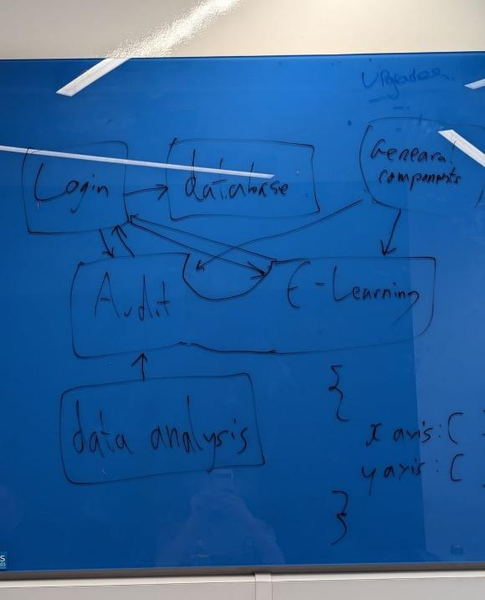

Figure 17.1: Draft architecture diagram

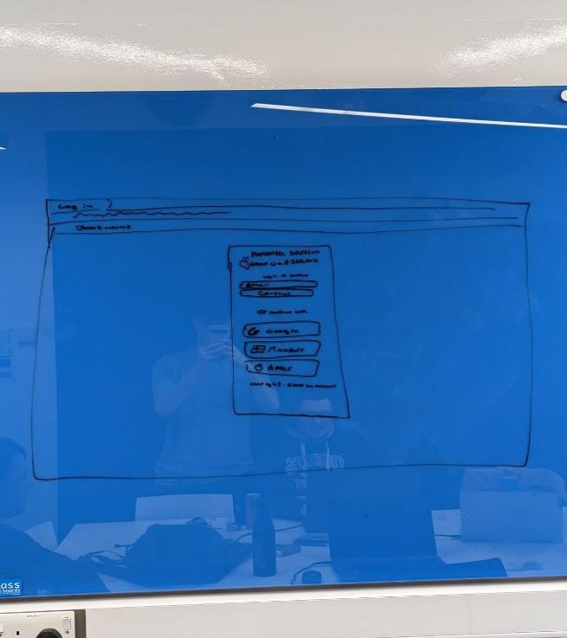

Figure 17.2: Draft login wireframe

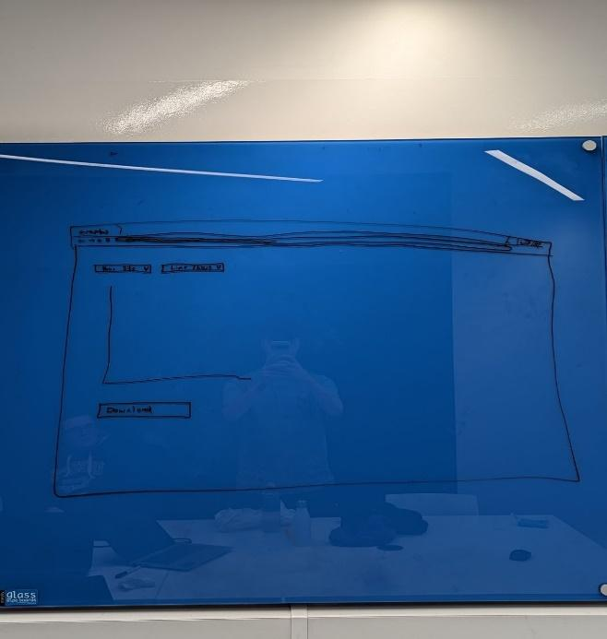

Figure 17.3: Draft audit graph wireframe

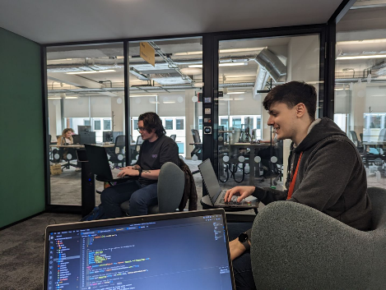

Figure 17.4: Robbie Duncan (Left) and Ewan Forsythe (Right)

collaborating on the prototype

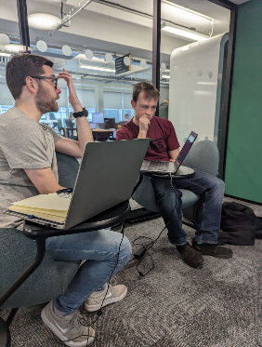

Figure 17.5: Adam Logan (Left) and Andrew Robb (Right)

collaborating on the prototype